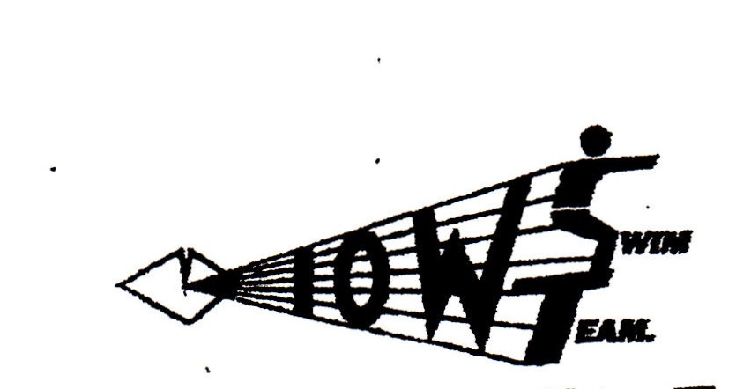
TEAM SELECTION SHEET
DATE:________SAT 15th November VENUE:________Basinstoke_______
Competition/Fixture: MINOR LEAGUE ROUND 2
Coaches Attending:__ TBC ___________Contact:__ coaches@seaclosesc.co.uk
Boys Team | Girls Team
Harry Elliott | Mia Curtis
Jamie Mursell | Lucy Kral
Gabe Wells | Lottie Van der Helstraete
 | Mia Stillwell
Josh Begg | Elysia Blacklock
Sean Joyce | Grace Bolland
Solomon Wells | Tilly Jones
Frank Morrison | Amber Wall
Morgan Evans | Abi Lacey
Ben Kral | Erin Lovely
Sam Cumpsty | Zoe Paulet
 | Charlotte Despard
Luke Blackman | Lelayna Blacklock
Michael Joyce | Megan King
Tom Kral | Amber Backhouse
Harvey Stillwell | Beth Elliott
Aidan Pierce | Renee Stewart
Alex Stewart | Emily Kral
James Stirling | Gemma Wall
Jordan Paulet | Eleanor King
Travel Arrangements
Meet Ryde Pier at__15.15 for ___15.47__p.m. Fast Cat.
Return Ryde Pier __22.35 (22.15 ferry)__
Please show your availability asap and if not available please advise on E MAIL .
********TEAM TRACKSUIT TOPS TO BE WORN AT ALL TIMES********

