WELCOME
TO
SEACLOSE SWIMMING CLUB
2014/2015

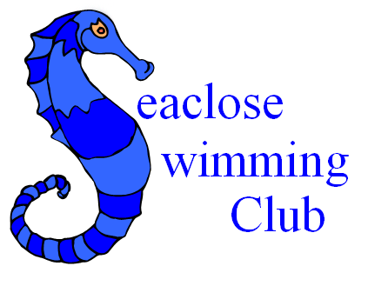

Seaclose Swimming Club
Affiliated to S.E.A.S.A & NaRS.
Medina Leisure Centre,
Fairlee Road,
Newport,
Isle of Wight

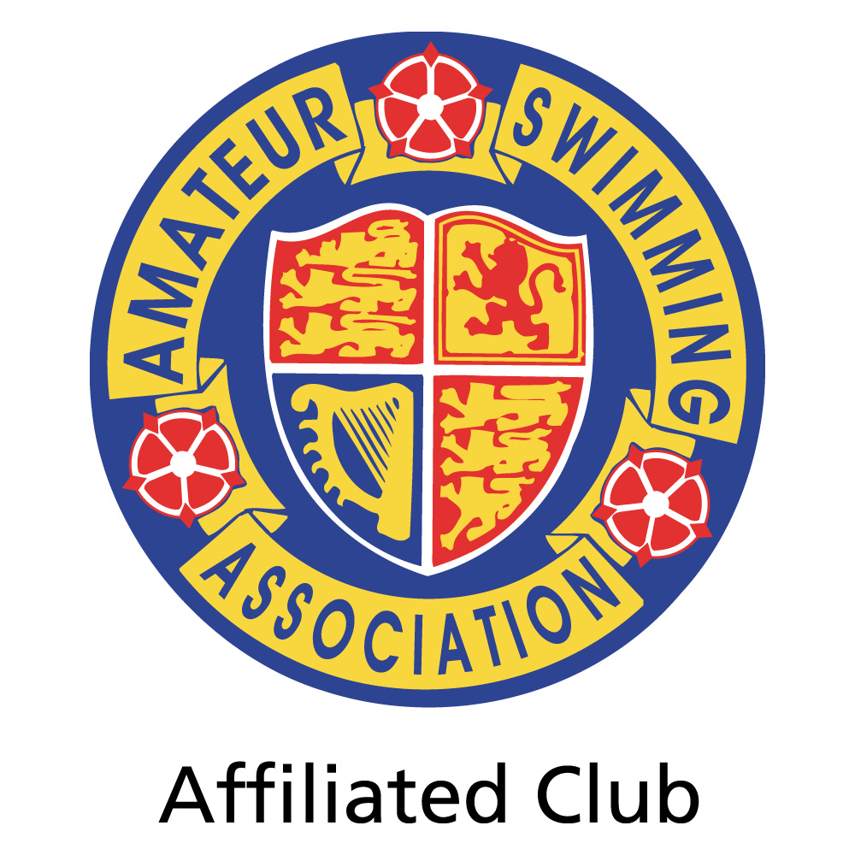
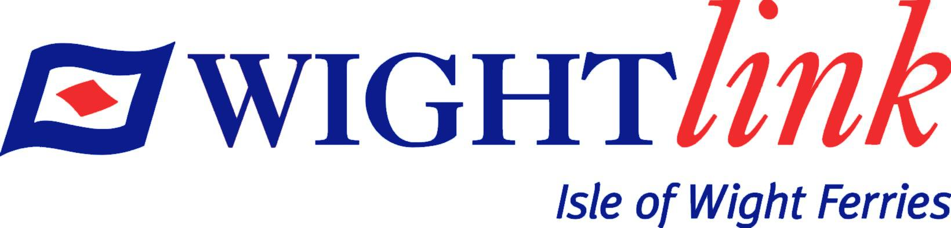
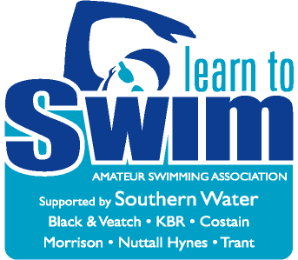
Kindly
Supported By

SEACLOSE SWIMMING CLUB was established in
September 1980 at Medina Leisure Centre. Before
this date they used Seaclose Park open-air pool
in Newport.
Our Aim is “To provide teaching and coaching for young people to reach their personal goal within the sport of swimming.”

Teaching Section:
We provide lessons for all levels from beginner to pre-competitive. All sessions run in 10 week blocks. Badges are attempted during lessons. No extra cost is charged for badges/certificates. Our prices are £32 for 10 x 30 minute lessons and £36 for a block of 10 x 45 minute lessons

Competetive Squads
Our Squads train 6 days a week. The swimmers compete under the name “Isle Of Wight Swim Team” in various mainland leagues and Cups. They also compete in inter club Island only competitions as well as our own club championships.

Teachers/Coaches:
Kindly
Supported By
All teachers, coaches, lifeguards and helpers hold A.S.A or S.T.A qualifications.
Gavin Muncaster, Val Gard, Dave Dutton, Ian Groves, Stuart Backhouse, Rosie Gard, David Blackman, Gloria Moreton, Paul Gwinnett, Hayley Landon, Sam Elliott, Kirsty Cook, Adrian Heng, Nathan Tombleson, Christine Tombleson, Rick Tombleson, Trevor Davies, Patricia Price, Beth Crockford.

Child Protection:
All volunteers working directly with the children are DRB checked and are members of the ASA/STA. They have also attended Safeguarding workshops. Our Child Protection Officer is SUE JOYCE.

Committee Members:
CHAIR – Ben Gard, VICE CHAIR – Ian Groves, TREASURER – Justin Elliott, SECRETARY – Naomi Evans, MINUTES SECRETARY – Emma Stevens, TEACHING SECTION – Katie Elliott, COACHING SECTION – Gavin Muncaster, MEDALS – Helen Blackman, SWIM 21 CO-ORDINATOR – Dave Dutton, OTHER MEMBERS – Justine Stewart

*SEACLOSE SWIMMING CLUB IS RUN BY MEMBERS FOR MEMBERS*

LEVEL 1 LEARNER STEPS SMALL POOL 30 MINUTES
Kindly
Supported By
AIMS 5 m front and back – very confident underwater
BADGES Puffin - Stanley 1,2&3 – Octopus 1 – 5m back and front – Water skills 1.

LEVEL 2 MIDDLE SECTION SMALL POOL 30 MINUTES
AIMS 10 m basic Backstroke – 10m basic Frontcrawl – 10 Breaststroke legs with float – Sitting dives & swimming underwater.
BADGES 10m front & back - Octopus 2&3 - Goldfish 1 - Waterskills 2.

LEVEL 3 END SECTION SMALL POOL 30 MINUTES
AIMS 25m basic Frontcrawl with breathing – 25m basic Backstroke – 25m basic Breaststroke – very confident in the deep end of the large pool.
BADGES 15,20 & 25m Front and back – Goldfish 2 & 3 – Angelfish 1 – Water skills 3.

LEVEL 4 SHALLOW END LARGE POOL 30 MINUTES
AIMS 50m Frontcrawl with correct breathing – 50m Backstroke – 25m Breaststroke – Treadwater – Surface dives – Various water confidence activities – Must be able to swim out of depth for 30 minutes.
BADGES 50m & 75m – Angelfish 2 & 3 – Water skills 4

LEVEL 5 DEEP END LARGE POOL 30 MINUTES
Kindly
Supported By
AIMS 50m Good Frontcrawl with breathing – 50m good backstroke – 50m good Breaststroke with breathing – Basic diving and water confidence activities.
BADGES 100, 200 & 400m – Shark 1& 2 – Water skills 5

LEVEL 6 LANES LARGE POOL 45 MINUTES
AIMS 200m Frontcrawl GOOD stroke – 200m Backstroke GOOD stroke – 200m Breaststroke GOOD stroke –Basic Butterfly – Turns and Competitive starts
BADGES 400 & 600m – Shark 3 – Water skills 6 – Bronze, Silver & Gold Challenge.

LEVEL 7 LARGE POOL 45 MINUTES
AIMS Building stamina – Working towards entry into Junior Squad and competition.
BADGES Competitive starts and turns – Distance badges 800 & 1500m+

